

Release Notes

TLM TFIM Version 3.2.4.0

**DISCLAIMER**

SmartStream Technologies makes no representations or warranties regarding the contents of this document. We reserve the right to revise this document or make changes in the specifications of the solution described within it at any time without notice and without obligation to notify any person of such revision or change.

**COPYRIGHT NOTICE**

2000 -2015 Copyright of SmartStream Technologies. All rights reserved. No part of this publication may be reproduced, stored in a retrievable system or transmitted, in any form or by any means, electronically, mechanically, photocopying, recording, or otherwise, without prior written permission from SmartStream Technologies.

**INTELLECTUAL PROPERTY WARNING**

The contents of this document and the software it describes are the intellectual property of SmartStream Technologies. The ideas contained in this document must not be disclosed to any third party.

**TRADEMARK NOTICE**

TLM® is a registered trademark of SmartStream Technologies. All rights reserved.

Other trademarks recognised and property of their respective owner.

**DOCUMENT INFORMATION**

Edition: 11 January 2016

Contents

1 Introduction 2

2 New Features & Enhancements 2

2.1 Enhancement in “Export all results” 2

2.2 New functionality “Copy” 2

3 Deliverables 3

3.1 Core System Deliverables 3

4 Level of Testing 3

5 Issues Resolved in this Release 4

5.1 TFIMX-7359 4

5.2 TFIMX-7335 4

5.3 TFIMX-7322 5

5.4 TFIMX-7131 5

5.5 TFIMX-7226 5

5.6 TFIMX-7215 6

5.7 TFIMX-7132 6

5.8 TFIMX-7130 6

5.9 TFIMX-7084 7

5.10 TFIMX-7137 7

# Introduction

This Software Release Note covers all system modifications for Version 3.2.4.0 of the TLM Transaction Fees and Invoices Management (TFIM) solution.

The release note lists the bug fixes and known issues provided in this release and are aimed at Operational Users of TFIM. These Release Notes do not aim to go into technical depth about specific changes or to be the basis for system testing.

# New Features & Enhancements

## Enhancement in “Export all results”

Exporting of records limit is increased upto 5,00,000 on selecting the “**Export all results**” button, which means the limit is increased from 3,00,000 to 5,00,000 in the various tabs such as Payer, Receiver etc. You can access this functionality via Data Processing menu.

## New functionality “Copy”

A new **Copy** functionality is introduced in this release to copy the records from the grid and to paste those values into excel. This enables the user to copy the maximum of 200 records at a time. You can select either one or multiple records as per the requirement and copy it to the excel sheet.

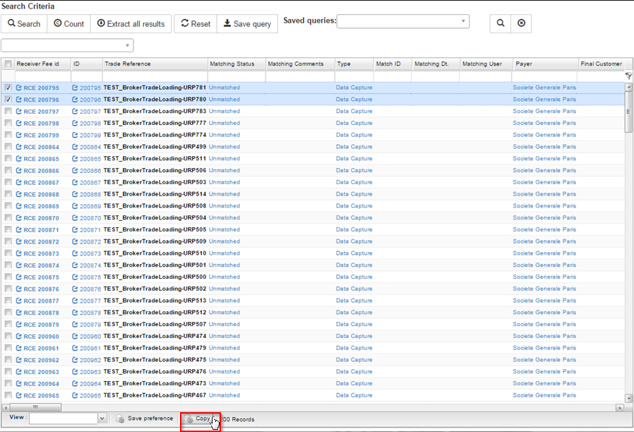

# Deliverables

## Core System Deliverables

|  |  |
| --- | --- |
| **File Name** | **File Version** |
| tfim3rda.war | 3.2.4 |
| tfim3.war | 3.2.4 |
| tfim3back.war | 3.2.4 |
| tfim3-master.jar | 3.2.4 |
| tfim3-server.jar | 3.2.4 |
| OpteamfeesEventServer.jar | 3.2.4 |
| 1_ADD_INDEX_EXTERNALMATCHID1_PFE.sql | 3.2.4 |
| 2_FIX_AGGREGATION.sql | 3.2.4 |
| 1_Calcul_Fiscalite_update.sql | 3.2.4 |
| 3_FLOW_STRATEGY.sql | 3.2.4 |

# Level of Testing

All issues that are listed in the section "**Issues Resolved in This Release**" have been tested. Targeted regression tests relating to the resolved issues have been performed.

# Issues Resolved in this Release

This section lists the issues that have been fixed in this release. The Likely Impact field in the tables below denotes the nature of the change, and the amount of testing that is recommended post implementation, as follows:

* Low - Minor change limited to a single component. Only minimal, targeted testing required.
* Medium - Relatively major change affecting a single component, or minor change affecting multiple components. Basic test of affected components recommended.
* High - A wide ranging change which has system-wide effects or involves the major refactoring of a key piece of functionality. Full system-wide functional test recommended.

## TFIMX-7359

|  |  |  |  |  |
| --- | --- | --- | --- | --- |
| **Issue No** | | **Description** | | **Priority** |
| TFIMX-7359 | | Fee computation/ Multiple aggregation bags are getting created for monthly fee schedule where as there should be only one aggregation bag for each month | | P1 |
| **Problem Reported** | | | | |
| For Peregrine Financial Group broker monthly fee schedules are setup, for which multiple aggregation bags were getting created in a month instead of single aggregation bag. Multiple aggregation bags result in higher fees and hence in matching it is identified as undercharged, where as for single aggregation bag this could very well computed as less fees and can be a valid Overcharged scenario eligible for dispute management. | | | | |
| **Likely Impact** | **Function (TFIM)** | | **Incident No** | |
| Low | Data Processing | | NA | |
| **Problem Solution Details** | | | | |
| Necessary changes have been added in Fee computation module to ensure that single aggregation bucket is created for monthly volumetric fee schedules. This has resolved the reported problem. | | | | |

## TFIMX-7335

|  |  |  |  |  |
| --- | --- | --- | --- | --- |
| **Issue No** | | **Description** | | **Priority** |
| TFIMX-7335 | | In the Schedulers, when defining the output's filename, we need some variables returning the Hours, Minutes and Seconds. | | P1 |
| **Problem Reported** | | | | |
| In the Schedulers, when defining the output's filename, we need some variables returning the Hours, Minutes and Seconds. This is because when multiple reports are generated in a day, the reports will be replaced by the latest one. In order to overcome this issue, the "#hh" returning the hours of the extract, "#mm" returning the minutes of the extract, "#ss" returning the seconds of the extract should be introduced. | | | | |
| **Likely Impact** | **Function (TFIM)** | | **Incident No** | |
| Low |  | | NA | |
| **Problem Solution Details** | | | | |
| Now you can generate multiple reports in a day and the reports are saved with the following format  Test_#yyyy#dd#MM#mm#ss#HH.THEIRTHREADS. | | | | |

## TFIMX-7322

|  |  |  |  |  |
| --- | --- | --- | --- | --- |
| **Issue No** | | **Description** | | **Priority** |
| TFIMX-7322 | | Change of “Appointment time” of Schedulers is not taken live into account. | | P1 |
| **Problem Reported** | | | | |
| None of the TFIM to TLM extract reports were automatically triggered or generated today as scheduled to run at 15:00 PM UK time. | | | | |
| **Likely Impact** | **Function (TFIM)** | | **Incident No** | |
| High | Settings | | NA | |
| **Problem Solution Details** | | | | |
| Necessary code changes have been added and now any changes in appointment time in scheduler are reflected. This has fixed reported problem. | | | | |

## TFIMX-7131

|  |  |  |  |  |
| --- | --- | --- | --- | --- |
| **Issue No** | | **Description** | | **Priority** |
| TFIMX-7131 | | Partial payments not working for Manual invoices | | P1 |
| **Problem Reported** | | | | |
| Currently, Partial payment function works only on automatic invoices, i.e. invoices for which both PF and RF are loaded. It doesn't work on manual invoices. We would want the partial payment functionality to work on manual invoices as well as we have started processing invoices manually for Newedge in TFIM. | | | | |
| **Likely Impact** | **Function (TFIM)** | | **Incident No** | |
| High | Data Processing | | NA | |
| **Problem Solution Details** | | | | |
| Necessary changes have been added to fix reported problem for Invoices in Manual Matching mode | | | | |

## TFIMX-7226

|  |  |  |  |  |
| --- | --- | --- | --- | --- |
| **Issue No** | | **Description** | | **Priority** |
| TFIMX-7226 | | The DIP Command "FR" not supporting to replace "," to "." | | P2 |
| **Problem Reported** | | | | |
| In Data Capture configuration the mapping function “FR” for amount fields is not replacing comma (,) with decimal point (.) as decimal separator. Because of this the amount in French is interpreted incorrectly. | | | | |
| **Likely Impact** | **Function (TFIM)** | | **Incident No** | |
| Medium | Data Processing | | NA | |
| **Problem Solution Details** | | | | |
| Now the mapping function is working as expected to replace comma (,) with decimal point (.) as decimal separator. This is used while reading amount in French locale. | | | | |

## TFIMX-7215

|  |  |  |  |  |
| --- | --- | --- | --- | --- |
| **Issue No** | | **Description** | | **Priority** |
| TFIMX-7215 | | RIA / Increase the limit of records provided by Extract all results to 500 000 (instead of 300 000) | | P2 |
| **Problem Reported** | | | | |
| While performing extract of all records from RIA using 'Extract all results' button presently there is a limit of 300000 records. This limit needs to be increased to 500000 records. | | | | |
| **Likely Impact** | **Function (TFIM)** | | **Incident No** | |
| Low |  | | NA | |
| **Problem Solution Details** | | | | |
| The "Export all results" tab in various tabs such as Payer, Receiver etc. limits has been increased from 300000 to 500000 records in RIA. | | | | |

## TFIMX-7132

|  |  |  |  |  |
| --- | --- | --- | --- | --- |
| **Issue No** | | **Description** | | **Priority** |
| TFIMX-7132 | | RIA: Error in Email on doing Extract all results on invoice | | P2 |
| **Problem Reported** | | | | |
| When we use the Extract all results function for invoices, the email which was generated had errors. | | | | |
| **Likely Impact** | **Function (TFIM)** | | **Incident No** | |
| Low | Data Output | | NA | |
| **Problem Solution Details** | | | | |
| This issue is fixed now, as no error occurs after the email is generated. | | | | |

## TFIMX-7130

|  |  |  |  |  |
| --- | --- | --- | --- | --- |
| **Issue No** | | **Description** | | **Priority** |
| TFIMX-7130 | | RIA: Error in the exported csv on doing Extract all results on cases | | P2 |
| **Problem Reported** | | | | |
| Errors in the exported csv on using the “Extract all results” functionality on cases. | | | | |
| **Likely Impact** | **Function (TFIM)** | | **Incident No** | |
| Low | Data Output | | NA | |
| **Problem Solution Details** | | | | |
| This issue is fixed now, as no error occurs in the exported csv file. | | | | |

## TFIMX-7084

|  |  |  |  |  |
| --- | --- | --- | --- | --- |
| **Issue No** | | **Description** | | **Priority** |
| TFIMX-7084 | | RIA/ List Grid/ Need to add support for Copy to Excel functionalities. | | P2 |
| **Problem Reported** | | | | |
| There is a need to add Copy to excel and Print functionality. | | | | |
| **Likely Impact** | **Function (TFIM)** | | **Incident No** | |
| Low | Data Processing | | NA | |
| **Problem Solution Details** | | | | |
| Necessary provision has been added in grid component to copy the content of selected records on clipboard. Now user can select required records and using Copy button at the bottom of grid to copy the content of selected record and paste the same in Excel. | | | | |

## TFIMX-7137

|  |  |  |  |  |
| --- | --- | --- | --- | --- |
| **Issue No** | | **Description** | | **Priority** |
| TFIMX-7137 | | RIA: Search condition empty, not empty not working on Payer Fees Screen and Receiver Fees Screen | | P3 |
| **Problem Reported** | | | | |
| On Empty and Not Empty selection for Search condition functionality on Payer Fees Screen and Receiver Fees Screen, no results are displayed and errors are seen in the logs. | | | | |
| **Likely Impact** | **Function (TFIM)** | | **Incident No** | |
| Low |  | | NA | |
| **Problem Solution Details** | | | | |
| The cause of this issue was IE8 specific and necessary code changes have been applied to resolve reported problem. | | | | |